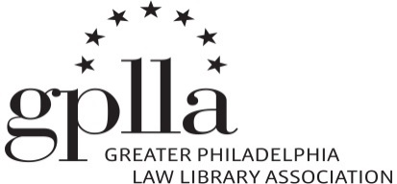
2023-2024
Grants Guidelines & Application

The Greater Philadelphia Law Library Association (GPLLA) Grants & Scholarships Committee administers funds to allow its members to attend educational programs, seminars, etc. relevant to law librarianship. The grants are aimed at law librarians and student members who demonstrate potential to contribute to GPLLA and to the profession as a whole.

Grants are awarded for an amount up to, but not exceeding, $795.00.

Grants & Scholarships Committee members are ineligible to receive grants during their tenure on the Committee. Grant recipients may receive only one grant award per year. New grant applicants will receive priority over previous recipients.

If circumstances arise which prevent a grant recipient from using any or all the grant funds, the funds will revert back to GPLLA and the recipient will be eligible to reapply in the future.

All grant funds shall be used for the designated meeting/workshop.

To be considered for a GPLLA Grant, a member MUST meet the following eligibility requirements and complete the following application guidelines.

Eligibility Requirements

An applicant must meet all of the below requirements to be considered for the grant:

(1) Be a current (dues paid) GPLLA member or student member; and

(2) Reside within the geographic area covered by GPLLA. The geographic area covered by GPLLA is comprised of Pennsylvania, New Jersey and Delaware. Preference will be given to applicants residing in the Tri-State area (generally understood to encompass the area of Pennsylvania east of the Susquehanna River, the area of New Jersey south of and including Trenton, and all of Delaware).

Application Guidelines:

(1) Submit a legibly completed GPLLA Grants Application, to be received at least 1 month prior to the discounted (Early-Bird) registration deadline for the proposed meeting or conference.

(2) Submit a brief personal statement which describes why you should receive a
grant, how attending the conference or workshop will assist you professionally,
your level of involvement in library activities, and any other information which you feel may aid the committee.

(3) Submit a current resumé.

(4) OPTIONAL: Submit one (1) letter of recommendation which address your potential to contribute to the chapter and to the law librarianship profession, and which address your need for the grant.

In selecting the grant recipients, the Grants & Scholarships Committee will consider the following factors:

- Genuine interest in the profession of law librarianship, as evidenced by the application materials, the applicant’s relevant professional activities, and proven or potential to contribute to GPLLA and the field of law librarianship.
- Any previous grants or scholarships to an applicant; however, such previous awards will not render the applicant ineligible for the grant.
- Financial need.

Grant recipients may be asked to write a brief description of their experience which may be shared with the members of the law librarianship community.

Each application will be considered on its own merits.

Completed applications should be directed to Genevieve Tung at gtung@law.upenn.edu. Please use “GPLLA Grant” as the subject line of the e-mail.

Incomplete or late applications will not be considered.

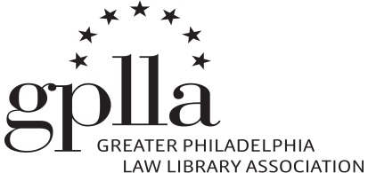
2023-24 Grants Application Form

Name: _________________________________________________________________

Address: ________________________________________________________________

Email: __________________________________________________________________

Current Position: _________________________________________________________

Have you previously received a GPLLA grant or scholarship? ______Yes ______No

Name, date(s), and sponsoring organization of the program you wish to attend:

________________________________________________________________________

________________________________________________________________________

Estimated expenses:
Registration: ___________
Lodging: ___________
Transportation: ___________

What amount will your employer contribute? _______________________________

PLEASE READ AND SIGN THE FOLLOWING:

I have read the GPLLA Grant Guidelines.

If the circumstances surrounding my application change materially after submission of this application, I shall immediately notify the Chair of the Grants & Scholarships Committee.

I understand and agree that if I receive a GPLLA Grant and if, for any reason, I fail to maintain the eligibility requirements for which the grant was awarded, I shall immediately notify the GPLLA Grants & Scholarships Chair. I understand that, depending on circumstances, I may be required to repay all or part of the grant.

Date: __________ Signed_________________________________________________

